**User Manual**

*Email Filtration/Notification System*

Team Giraffe, Software Engineering Spring 2020

April 2020

**Revisions**

|  |  |  |
| --- | --- | --- |
| **Version** | **Date** | **Revision Description** |
| 0.1 | 04/27/2020 | Initial Writing |
| 0.2 | 5/1/2020 | Finished General Information |
| 0.3 | 5/3/2020 | Added and finished System Summary |
| 0.4 | 5/7/2020 | Added and finished Getting Started |
| 0.5 | 5/9/2020 | Added and finished Using the System |
| 1.0 | 5/10/2020 | Minor revisions, first release |

**Table of Contents**

**1. General Information** **4**

1.1 System Overview 4

1.2 Authorized Use Permission 4

1.3 Organization of Manual 4

1.4 Acronyms and Abbreviations 4

**2. System Summary** **6**

2.1 System Configurations 6

2.2 User Access Levels 6

2.3 Contingencies 6

**3. Getting Started** **7**

3.1 Logging On 7

3.2 System Menu 7

3.2.1 Notification Tab 8

3.2.2 Pinned Notification Tab 8

3.2.3 Snoozed Notification Tab 9

3.2.4 Settings Tab 10

3.3 Changing User Email and Password 11

3.4 Exit System 11

**4. Using the System** **12**

4.1.1 Adding a bucket 12

4.1.2 Removing a Bucket 12

4.1.3 Adding a Keyword 13

4.1.4 Viewing a Notification 14

4.1.5 Removing a Notification 15

4.2 Special Instructions for Error Connections 15

4.3 Caveats and Exceptions 15

# 1. General Information

## 1.1 System Overview

The Email Filtration/ Notification system is an application that takes in incoming emails and sends a notification to the user if the email is deemed important. The application makes use of Rowan University’s Google Mail service to read in the emails.

## 1.2 Authorized Use Permission

Everyone at Rowan University is able to download and use the application. Those considered administration at Rowan University may push specialized emails to its users.

## 1.3 Organization of Manual

The user’s manual consists of four different sections: General Information, System Summary, Getting Started, and Using the system.

The General Information section details the general purpose of the system and its intended uses.

The System Summary section details the specifications of the system. This includes software requirements, system hardware, system configurations, user access levels, and contingencies.

The Getting Started section details how to log on to the application, log off the system, and briefly describes the system menu.

The Using the System section details various different features and functions of the application.

## 1.4 Acronyms and Abbreviations

Here is a list of words that will be used throughout the user manual that may need some explanations:

* Admin: shorthand for administration.
* Bucket: a place where a collection of email notifications tied to an email address live in the system.
* GMail: a shorthand for Google Mail
* Keyword: a word set by the user to filter emails by to see if the email is deemed important.
* Notification: an alert to the user that the application will send to the user’s device.

# 2. System Summary

## 2.1 System Configurations

The Email Filtration/Notification system is a mobile application that runs on the Android operating system. It is compatible with Android 10 API level 29 or higher. The application requires an Internet connection to connect to the GMail servers.

## 2.2 User Access Levels

Everyone at Rowan University can use the application. Users that are deemed admins are able to send emails that elicit a special notification.

## 2.3 Contingencies

In the event that the user cannot connect to the Internet, the user can opt to use their data to connect to the GMail servers. In the event that the user’s device turns off unexpectedly while using the application, the user can relaunch the application and nothing is lost.

# 

# 3. Getting Started

## 3.1 Logging On

To log on to the application, use your Rowan University email and Rowan password to access the application (Figure 3.1).

**Figure 3.1 Login Screen**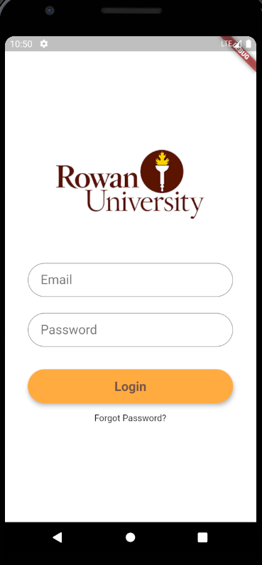

## 3.2 System Menu

The Email Filtration/Notification system is a tabbed system that is broken into three (3) tabs (Figure 3.2). Each tab displays different types of notifications that are sent to the user. Each tab is labeled with a name so the user knows what tab they are on. The “Settings” tab is marked as a gear in the upper right corner.

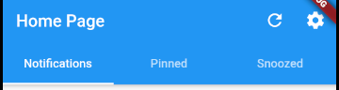

**Figure 3.2 Main Menu Bar**

### 3.2.1 Notification Tab

The “Notification” tab handles the general notifications that come through.

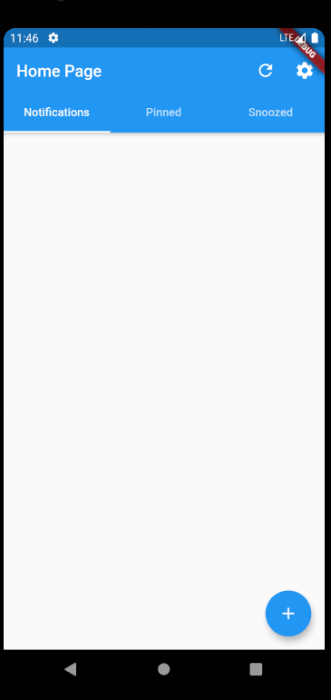

**Figure 3.2.1 Notification Menu**

### 3.2.2 Pinned Notification Tab

The “Pinned” tab handles any notifications that the user has pinned for later viewing.

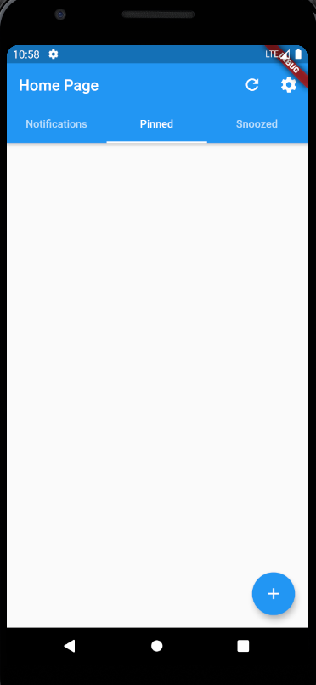

**Figure 3.2.2 Pinned Menu**

### 3.2.3 Snoozed Notification Tab

The “Snoozed” tab handles any notifications that the user has snoozed when they received the notification.

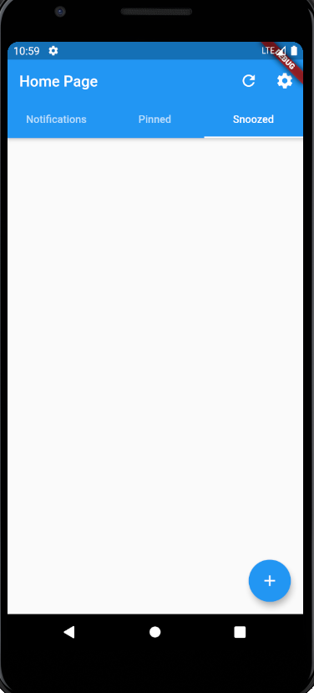

**Figure 3.2.3 Snoozed Menu**

### 3.2.4 Settings Tab

The “Settings” tab allows the user to modify various settings within the application, such as receiving a notification, editing the email list, and others.

**Figure 3.2.4 Settings Menu**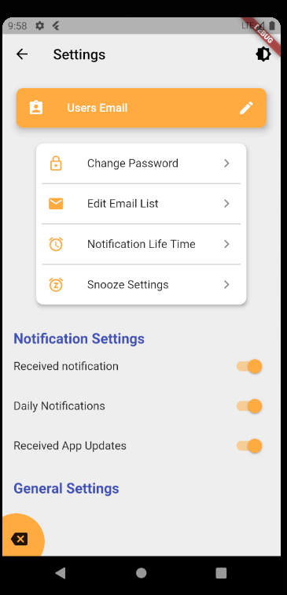

## 3.3 Changing User Email and Password

The Rowan email cannot be changed. The password to the email account can be changed through the official Rowan University website.

## 3.4 Exit System

Users are able to exit the application by pressing the ‘Back’ button on their device. Alternatively, you can press the “Log out” button on the Settings page to log out of the system.

# 

# 4. Using the System

### 4.1.1 Adding a bucket

To add a bucket, the user presses the circular, blue “+” button at the bottom right of the screen. Once pressed, the user is able to insert a name for the bucket and an email address (Figure 4.1.1.1). Once the user is done with adding a name and an email address, the user then presses the “Add” button to add the bucket to the Notifications Menu (Figure 3.2.1). A completed bucket will look like Figure 4.1.1.2

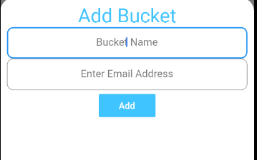

**Figure 4.1.1.1 Add Bucket Menu**

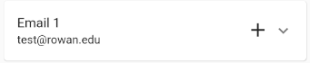

**Figure 4.1.1.2 Completed Bucket**

### 4.1.2 Removing a Bucket

If a user wishes to remove a bucket, the user has to navigate to the Settings menu (Figure 3.2.4). Once there, the user then clicks on the “Edit Email List.” A menu similar to Figure 4.1.2.1 will appear. Follow the onscreen instructions to remove a bucket.

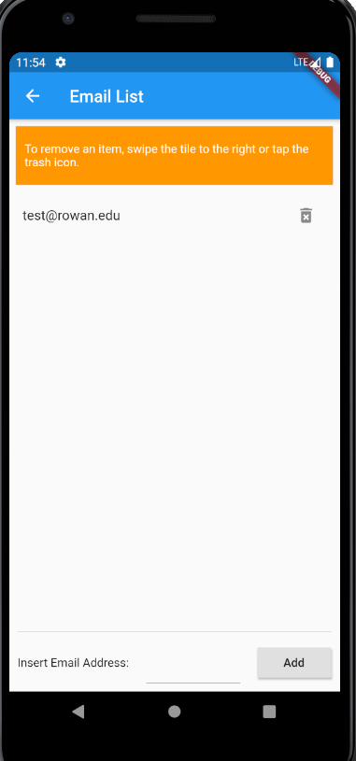

**Figure 4.1.2.1 Edit Email List Menu**

### 4.1.3 Adding a Keyword

A user is able to add a filter to their buckets to specify what emails the user wants to be notified of. To add a keyword, the user first presses the plus button (“+”) on the bucket they wish to add a keyword to (Figure 4.1.1.2). Once there, the user is able to type out a single word that the system will use to filter out emails (Figure 4.1.3.1). Once the user is satisfied, they can press the “Add” button to apply the keyword to the bucket.

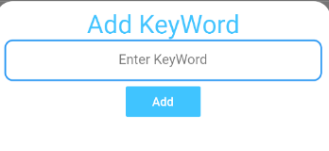

**Figure 4.1.3.1 Keyword Menu**

### 4.1.4 Viewing a Notification

When the application detects an email that matches a bucket’s filter, it will send a notification to the user. Two notifications will occur in the system: a push notification and a notification within the application as well. A push notification will alert the user that they have received a notification (Figure 4.1.4.1). A notification within the application (Figure 4.1.4.2) will show where in the email the filter filtered out that email, if applicable; otherwise, it will list the email with the subject and a snippet of the body.

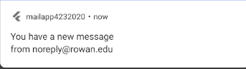

**Figure 4.1.4.1 Push Notification from the Application**

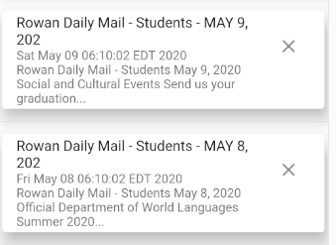

**Figure 4.1.4.3 Notifications within the Application**

If a user presses on the notification, they will be redirected to their email inbox to view the email.

### 4.1.5 Removing a Notification

If a user desires, they can remove notifications within the application. All that the user has to do is press the “X” next to the notification to remove it (see Figure 4.1.4.3 for location).

## 4.2 Special Instructions for Error Connections

In the event that you are unable to connect to their email, try changing the security settings on the Rowan email to enable ‘Low Access Applications.’

## 4.3 Caveats and Exceptions

One exception to the system that the user should know is that the system relies on valid email addresses in the user’s inboxes. If a user makes a mistake in the email that they want a bucket for, they can remove the bucket and re-add it with the correct email address.